Thevenin And Norton Equivalent Circuits

&

Maximum Power Transfer

Experiment 1 & 2

Justin Fortner

February 10th, 2018

Section 04 Wednesday 12:20-2:20 (Tuwin)

**Introduction**

The purpose of lab 2 was to allow students to see first the rules and logic behind Thevenin and Norton equivalent circuits as well as maximum power transfer,

Experiment 1 focuses on Thevenin and Norton equivalent circuits. Thevenin circuits consist of a voltage source and a resistor in series with a load resistance. Thevenin circuits satisfy KVL by allowing the voltage of the voltage source to be equal to the sum of the voltage across each resistor. Norton circuits, however consist of a current source ins parallel with a resistance. These elements are then in parallel with another load resistance. Norton circuits satisfy KCL. Both Thevenin and Norton circuits are used to simplify more complicated circuit networks.

Experiment 2 focuses on maximum power transfer. The maximum power transfer theorem states that the maximum amount of power that is able to be transferred into a load occurs when the load resistance is equal to the source resistance.

**Thevenin And Norton Equivalent Circuits**

The circuit in figure 1 must be replicated in order to continue on in the experiment.

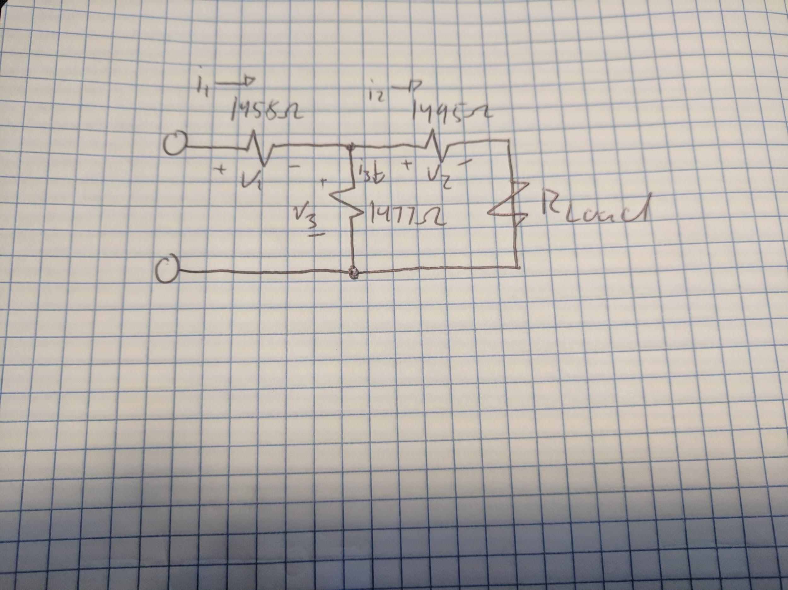

**Figure 1**

Resistor Circuit Schematic for Lab 2, Experiment 1

The input voltage was set to a constant 10 Volts. The actual resistances of R1, R2 and R3 can be seen in **Figure 2**. From this circuit the Thevenin and Norton equivalent circuits must be found. The outline for these circuits can be found in **Figure 3.**

|  |  |  |  |  |
| --- | --- | --- | --- | --- |
| Resistor | Nominal (Ohm) | Measured (Ohm) | Absolute Difference (Ohm) | Relative Difference |
| R1 | 1500 | 1458 | 42 | 2.8% |
| R2 | 1500 | 1495 | 5 | .33% |
| R3 | 1500 | 1477 | 23 | 1.53% |

**Figure 2**

Values of the Resistors for the Circuit for Lab 2, Experiment 1

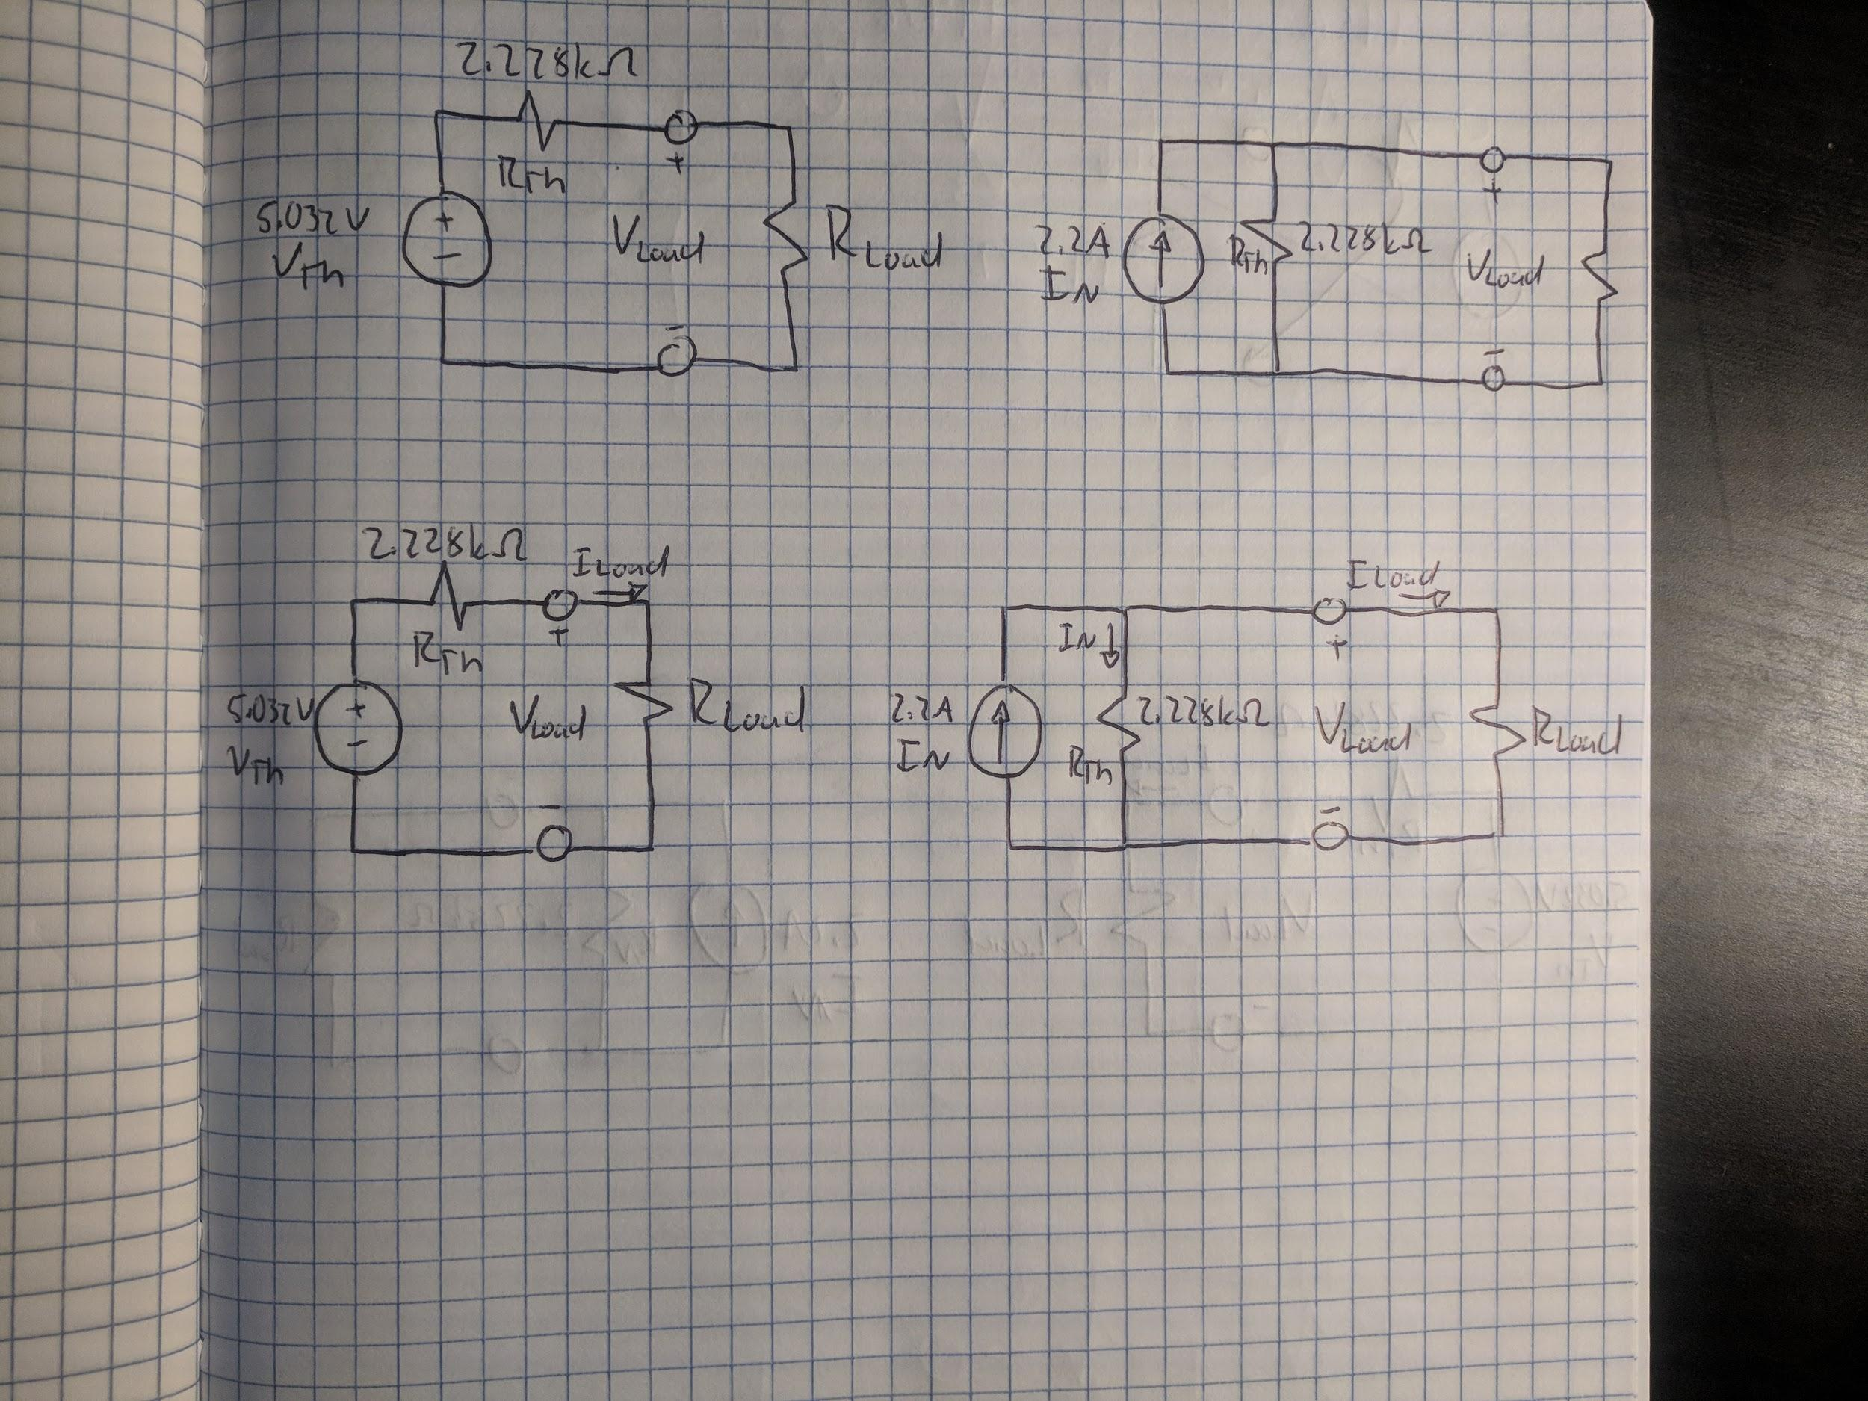

**Figure 3**

Thevenin and Norton Schematic for Lab 2, Experiment 1

In order to measure the Thevenin voltage, R load was removed from the circuit leaving an open circuit. The multimeter was then hooked up to the two output nodes and set to measure the voltage. The Thevenin voltage was found to be 5.032 Volts.

The Thevenin resistance was measured next. In order to do this the Voltage source was removed and replaced with a wire to create a short circuit. The multimeter still connected to the two output nodes was then set to measure the resistance. The Thevenin resistance was found to be 2.228 kOhms.

The Norton current can be calculated by dividing the Thevenin voltage by the Thevenin resistance(). The result of this being 2.2 amps.

The Norton resistance is equal to the Thevenin Resistance, 2.228 kOhms.

Once the Thevenin and Norton circuits were found a variable resistance was used on order to analytically show that both the Thevenin’s and Norton’s equivalent circuit can be used to accurately predict and load current and voltage. The experiment circuit can be seen in **Figure 4.**

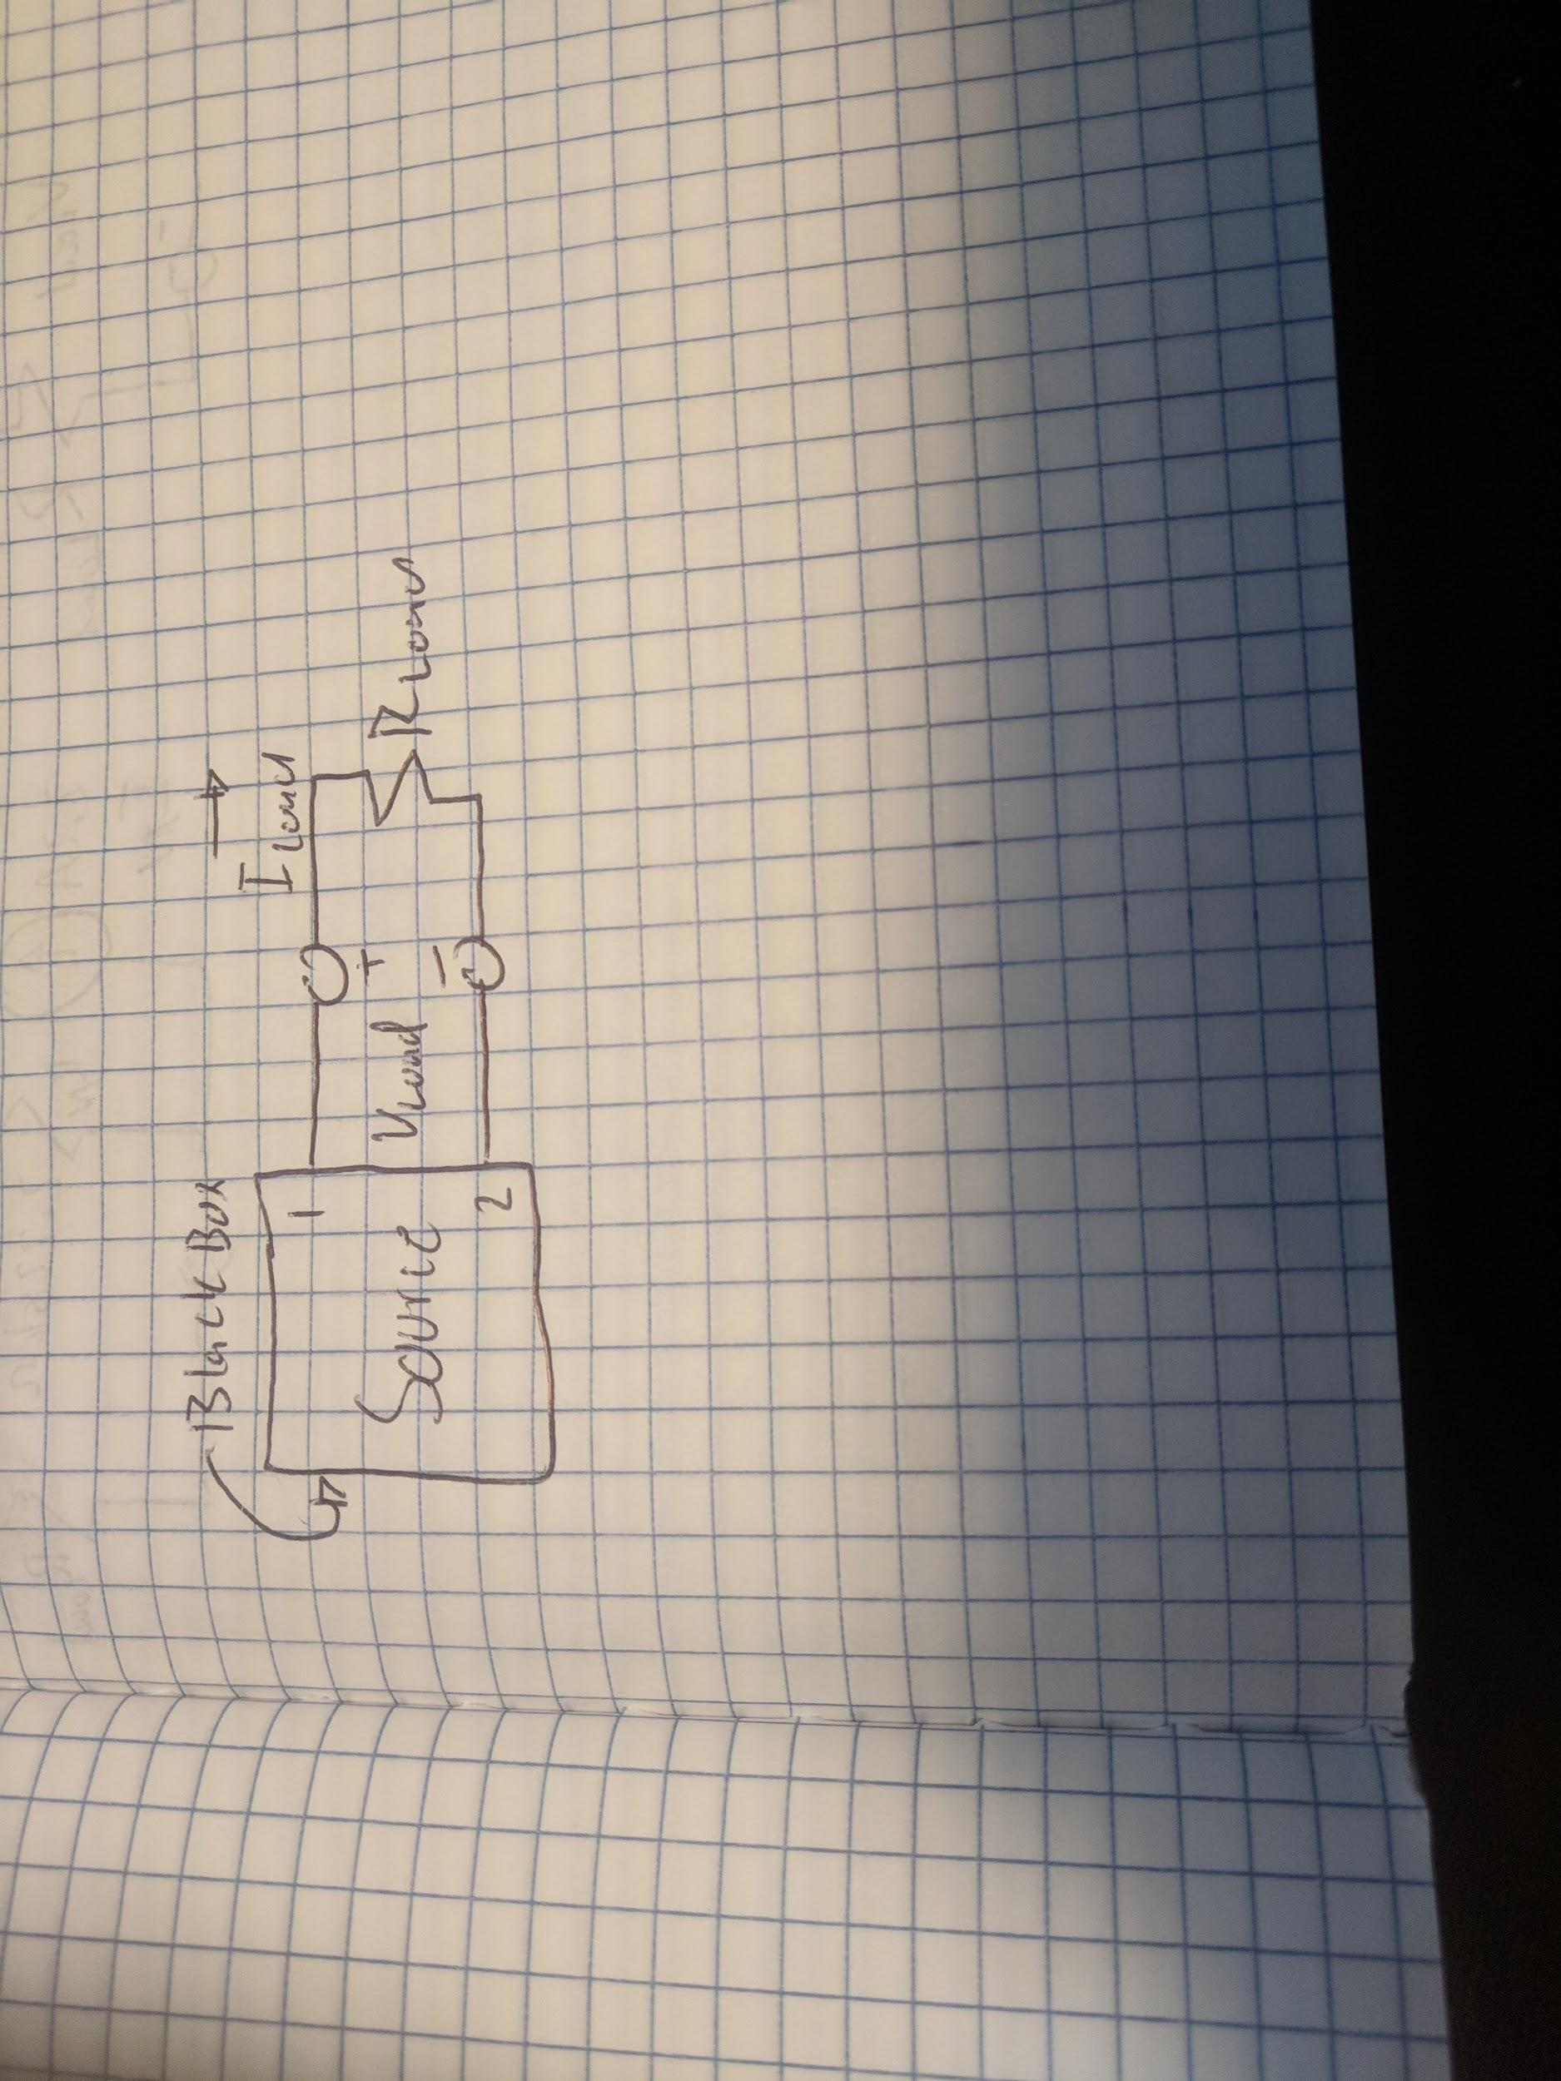

**Figure 4**

“Black Box” Schematic for Lab 2, Experiment 1

The expected value of the load current and voltage compared to the actual load and current voltages can be seen below in **Figure 5** and **Figure 6.**

|  |  |  |  |  |  |  |
| --- | --- | --- | --- | --- | --- | --- |
| R Load | V Load Expected | V Load Experimental | % Difference | I Load Expected | I Load Experimental | % Difference |
| 1 k | 1.56 V | 1.56 V | 0% | 1.56 mA | 1.55 mA | .6% |
| .94 k | 1.495 V | 1.486 V | .6% | 1.59 mA | 1.59 mA | 0% |
| .834 k | 1.37 V | 1.357 V | .9% | 1.643 mA | 1.666 mA | 1.3% |
| .723 k | 1.233 V | 1.275 V | 3.4% | 1.705 mA | 1.757 mA | 3% |
| .611 k | 1.082 V | 1.046 V | 3.3% | 1.772 mA | 1.839 mA | 3.8% |
| .492 k | .91 V | .856 V | 5.9% | 1.85 mA | 1.946 mA | 5.1% |
| .29 k | .579 V | .583 V | .6% | 1.998 mA | 2.155 mA | 7.8% |
| .141 k | .299 V | .260 V | 1.3% | 2.12 mA | 2.153 mA | 1.2% |

**Figure 5**

Thevenin’s Equivalent Circuit Comparison for Lab 2, Experiment 1

|  |  |  |  |  |  |  |
| --- | --- | --- | --- | --- | --- | --- |
| R Load | V Load Expected | V Load Experimental | % Difference | I Load Expected | I Load Experimental | % Difference |
| 1 k | 1.56 V | 1.59 V | 1.92% | 1.56 mA | 1.518 mA | 2.7% |
| .94 k | 1.495 V | 1.41 V | 5.6% | 1.59 mA | 1.61 | 1.25% |
| .83 k | 1.37 V | 1.38 V | .7% | 1.643 mA | 1.65 mA | .4% |
| .723 k | 1.233 V | 1.222 V | .9% | 1.705 mA | 1.81 mA | 6.1% |
| .611 k | 1.082 V | 1.1 V | 1.6% | 1.772 mA | 1.74 mA | 1.8% |
| .492 k | .91 V | .9 V | 1.1% | 1.85 mA | 1.846 mA | .2% |
| .290 k | .579 V | .62 V | 7% | 1.998 mA | 2.07 mA | 3.6% |
| .141 k | .299 V | .287 V | 4% | 2.12 mA | 2.21 mA | 4.2% |

**Figure 6**

Norton’s Equivalent Circuit Comparison for Lab 2, Experiment 1

The average percent difference of voltage across the load for the Thevenin’s equivalent is 2%. The average percent difference of current across the load for the Thevenin’s equivalent is 2.85%. The average percent difference of voltage across the load for the Norton’s equivalent is 2.85%. The average percent difference of current across the load for the Norton’s equivalent is 2.53%. With a maximum difference of only 2.85% between any expected value and its corresponding experimental value, one can make the conclusion that both engineering models can be used to accurately predict any load current and voltage within the range permitted by the source. This error can be explained by the fact that I assumed the power supply is ideal when in fact it is not.

Question: How ideal is the power supply and does it need to be taken into account?

Answer: The power is not ideal. There is a resistance caused by the wire between the power supply and the bread board. This it must be taken into account when doing many of the calculations involved in this lab. I did this lab assuming the power supply was ideal and thus my expected numbers are slightly off of my experimental numbers.

**Maximum Power Transfer**

For this experiment the Thevenin’s circuit seen on the left side of **Figure 3** waws recreated. The goal is to experimentally prove the maximum power transfer theorem. The maximum power transfer theorem states that the maximum amount of power that is able to be transferred into a load occurs when the load resistance is equal to the source resistance. This was shown by using three different load resistances, one smaller, one equal to and one bigger than the Thevenin’s resistance. The load resistances and resulting power outputs can be seen in **Figure 7, 8 and 9** respectively.

|  |  |  |  |
| --- | --- | --- | --- |
|  | Thevenin’s Resistance | Load Resistance | Total |
| Voltage | 4.94 V | 51.05 mV | 4.99 V |
| Current | 1.09 mA | 1.09 mA | 1.09 mA |
| Resistance | 2.25 kOhm | 47 Ohm | 2.297 kOhm |
| Power | 5.38 mW | .0556 mW | 5.44 mW |

**Figure 7**

Small Load Resistance for Lab 2, Experiment 2

|  |  |  |  |
| --- | --- | --- | --- |
|  | Thevenin’s Resistance | Load Resistance | Total |
| Voltage | 3.73 V | 3.73 V | 7.46 V |
| Current | 1 mA | 1 mA | 1 mA |
| Resistance | 2.25 kOhm | 2.25 kOhm | 4.5 kOhm |
| Power | 3.73 mW | 3.73 mW | 7.46 mW |

**Figure 8**

Equal Load Resistance for Lab 2, Experiment 2

|  |  |  |  |
| --- | --- | --- | --- |
|  | Thevenin’s Resistance | Load Resistance | Total |
| Voltage | 3.32 V | 1.64 V | 4.96 V |
| Current | 1 mA | 1 mA | 1 mA |
| Resistance | 2.25 kOhm | 4.4 kOhm | 6.65 kOhm |
| Power | 3.32 W | 1.64 W | 4.96 W |

**Figure 9**

Bigger Load Resistance for Lab 2, Experiment 2

As shown by the total power output of the three separate circuits, the maximum power output is achieved when all of the power from the Thevenin’s circuit is transferred to the load resistance. This only occurs when the load resistance is equal to the Thevenin’s resistance. The 7.46mW (equal resistance) is bigger than the 4.96mW (bigger resistance) and the 5.44mW (smaller resistance). More power measurements were taken and can be seen in the following graph in **Figure 10**.

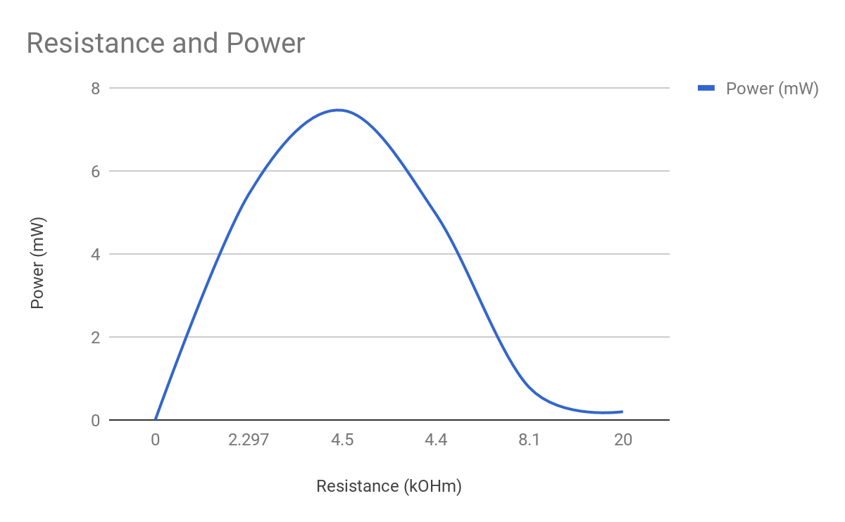

**Figure 10**

Resulting Power for Lab 2 Circuits, Experiment 2

The maximum power transfer is still achieved when the load resistance is equal to the Thevenin Resistance. Thus proving the maximum power transfer theorem. Also note that the power approaches zero as the resistance approaches infinity.

**Conclusion**

I had an extremely successful lab in lab 2. I successfully completed both experiments in full as well as learn a great deal.

For experiment 1, I successfully created both the Thevenin and Norton equivalent circuit. I successfully calculated the Thevenin voltage, Thevenin resistance and Norton current. I was able to add a variable load to both the Thevenin and Norton circuit and analytically show that both engineering models can be used to predict and load current and voltage.

For experiment 2 I successfully proved the maximum power transfer theorem by changing the load resistance and comparing the maximum power output of each of these circuits. The maximum power was achieved by using a load resistance that was equal to the Thevenin resistance.

This was a great lab, I accomplished and learned a lot. I was able to not only memorize but understand the key aspects of this lab.